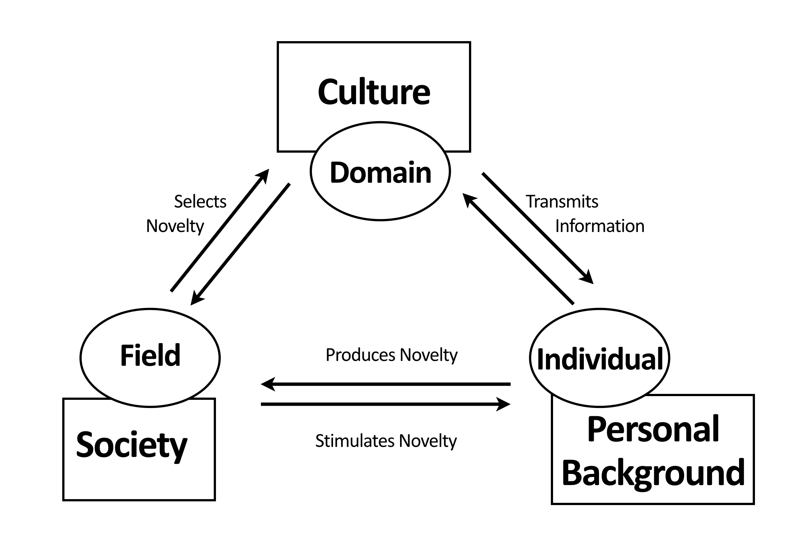
Figure 2. The system model of creativity. Redrawn after (Csikszentmihalyi, 1999/2010)

