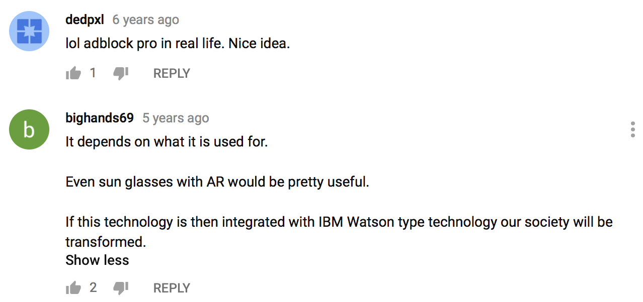
Figure 10. Screenshot of comment section on Youtube, Hidden Creative’s ‘The Future of Augmented Reality’ (captured 20 June 2018).

