Testing popular news discourse on the “echo chamber” effect: Does political polarisation occur among those relying on social media as their primary politics news source?

An Nguyen, Bournemouth University, UK
Hong Tien Vu, University of Kansas, USA

Abstract
Since 2016, online social networks (OSNs), especially their “big data” algorithm, have been intensively blamed in popular news discourse for acting as an echo chamber that entraps like-minded voters in closed ideological circles and engenders political polarisation, with serious damages to democratic processes. This study examines this “echo chamber” argument through the rather divisive case of EU politics among EU citizens. Based on an exploratory secondary analysis of the Eurobarometer 86.2 survey dataset, we investigate whether the reliance on OSNs as a primary EU politics news source can lead people to more polarisation in EU-related political beliefs and attitudes than such reliance on legacy media. We found little evidence of this polarisation, which lends credence to a rejection of the “echo chamber” argument.

Keywords
Echo chamber, filter bubble, political polarization, populist politics, digital news use, social news, EU politics

Introduction
The negative impact of online social networks (OSNs) on democracy has been a subject of intensive and extensive news coverage since the two seismic political events of 2016, the British vote to leave the EU and the American decision to send Donald Trump to the White House. At the centre of such misgivings and fears is the belief that OSNs function as “echo chambers” where like-minded voters, through self-selection and big data-based customisation algorithm, gather to consume and share ideologically agreeable news and information, including a vast quantity of mis- and dis-information (e.g. Bartlett 2016, Benton 2016, Preston 2017, Sillito 2016, Tait 2017, The Economist 2017a, The Economist 2017b, Wolff 2016). Such narrow circles of like-minded peers are formed, as this line of argument goes, at the expense of a comprehensive, multi-perspectival and evidence-based understanding of public affairs. Ultimately, this is believed to engender political polarisation between ideologically ingrained and/or emotionally charged segments of the public. For instance, the right-wing polarisation among anti-establishment segments of the public, which was seen as the key factor behind Brexit and Trump’s presidency, has been attributed to customisation algorithms on social platforms such as Facebook, especially the way they were maliciously used for political marketing by the like of the now notorious and default Cambridge Analytica. As a telling example, one of the few research firms that correctly predicted both Brexit and Trump’s presidency was a novice South African data-mining company called Brandseye, whose methodology was based entirely on analysing social media posts to algorithmically rate voter sentiments about politicians (Reuters 2016).
This paper sets out to demonstrate that as logical as it might sound at first glance, such news discourse around the politically polarised “echo chamber” on social media deserves a closer inspection. We will first review and assess this discourse’s underlining assumption to prove that recent empirical research based on more nuanced theoretical perspectives has much more often rejected than supported it. To add to this body of research evidence, we will then present data from a secondary analysis of the 2016 EU Barometer survey, which we used to probe for the existence of the “echo chamber” in the case of EU politics. In particular, we asked whether reliance on OSNs as the primary source of EU politics news engenders more political polarisation in EU beliefs and attitudes than that on four legacy media (radio, television, printed newspapers and non-OSN news sites). The results provide little evidence to support the “echo chamber” effect of OSNs on ideological processes.

“Echo chamber” in popular news discourse: a democratic disaster in the making?
The idea of social media acting as an “echo chamber” is nothing too strange to the news media. In 2011, Eli Pariser received substantial news coverage after publishing a rather alarming book on the rise of the so-called ideological “filter bubble” in digital media – which many today use interchangeably, although not correctly, with “echo chamber” (Bruns 2017) – and its potential harms to the way we live and operate. A few years before that, Andrew Keen (2007) warned in The Cult of the Amateur of a future in which increasing reliance on personalised social networks such as Facebook would lead people eventually to trusting their friends and crowds of amateurs more than people with professional expertise and talent such as journalists, with disastrous consequences on public life.
It was, however, not until the aftermath of the Brexit vote and then the Trump election that journalists started to intensively sound the alarm and continuously express deep misgivings and anxieties about the “insidious” long- and short-term harms of social networks’ “echo chamber” effect (e.g. Benton 2016, Tait 2017, The Economist 2017a, The Economist 2017b). In the eyes of newspeople, as Facebook algorithms and the like entrap voters in narrow circles of like-minded peers, people feel more “liable to interact” with like-minded content, thus less exposed to and more insulated from ideas and perspectives not resonant with their values and beliefs. In such close circles, moderate views can be turned into extreme ones, leading to polarisation. An editorial by The Economist (2017a) quoted scholar and columnist Zeynep Tufekci as saying: “It’s like you start as a vegetarian and end up as a vegan.”
This resembles what Bartlett (2015) calls the “self-brainwashing” process, “where certain ideas are repeated so often and with no contrary or alternative point of view that it fulfils the classic definition of brainwashing.” As Bartlett (2016) later writes in the New York Times, “those who inhabit this world live in a kind of bubble sometimes called ‘epistemic closure’, where they won’t believe many things taken for granted by people who get news from other sources.” This is particularly disturbing for journalists, as polarisation has proved to be a catalyst for mis- and dis-information – especially “fake news” – on social networks. The former editor of the Guardian, Peter Preston (2016), lamented that the first casualty of the post-truth world is the further erosion of public trust in quality news. Using the “epistemic closure” concept, Preston feared that the increasingly polarised political world might lead people to abandon quality journalism “in favour of partisan reporting or no reporting at all.” As he wrote:

(An) epistemic closure, succoured by algorithmic selection, trusts only what it sees plonked in front of it. Trust what Facebook and Google put on your plate. Trust the view of the world that most fits your needs. Trust what you see as “yourself.” No kitemark is going to offer a different sort of closure there. The whole concept of trust is changing. How do you deal with fairness and balance in an era of post-factual politics?

Meanwhile, Amelia Tait (2016) of the New Statesman calls attention to other, non-political but crucial, factors. As she argues, although self-brainwashing has long taken place among American viewers of Fox News and British readers of the Daily Mail or the Sun, it happens on a much larger scale today because social platforms “give people the illusion of being more informed in a way that a cursory glance at headlines never could.” This extraordinary influence, for Tait, comes in part from the economics of a largely unregulated social media industry: as their business model relies on user engagement as the currency, “it’s not in [their] best interests to remove news stories that resonate with their readers – even if they are untrue.” This explains why, for example, teenagers from a small Macedonian village could make handsome money from faking and sharing pro-Trump stories on Facebook. The Economist (2017b) echoes this point in more detail in an editorial:

[Social media] make their money by putting photos, personal posts, news stories and ads in front of you. Because they can measure how you react, they know just how to get under your skin. They collect data about you in order to have algorithms to determine what will catch your eye, in an “attention economy” that keeps users scrolling, clicking and sharing – again and again and again. … It would be wonderful if such a system helped wisdom and truth rise to the surface. But … truth is not beauty so much as it is hard work – especially when you disagree with it. Everyone who has scrolled through Facebook knows how, instead of imparting wisdom, the system dishes out compulsive stuff that tends to reinforce people’s biases.

As logical and coherent as it might sound, however, such popular news discourse about the “dark power” of social media becomes rather problematic, both theoretically and empirically, in the context of recent scholarly research.

“Echo chamber” in research literature: a mixed bag of evidence
At the very basic level, the premise of the echo-chamber concept should be scrutinised and challenged as it seems to subsume social news audiences to a very passive role – merely as “lumps of clay” easily moulded by algorithms. This, as decades of audience research has shown, is at least oversimplified and unhelpful for us to understand the complex socio-psychological dynamics of public reception of and connection to news and media content. More importantly, popular discourse about the echo chamber ignores an emerging body of empirical research evidence that is in direct contradiction with its assumption.
Social media uses, for instance, have been shown to either have a limited influence (Dimitrova, Shehata, Stromback & Nord 2014) or a significant positive effect (Gil de Zúñiga, Jung & Valenzuela 2012) on political knowledge. Further, social media are only one of the many possible media-related factors that contribute to political polarisation. In a large cross-national survey in 10 countries, for example, Yang et al (2015) found that general online news consumption – rather than “social news” use per se – consistently predicted polarization on controversial political issues that were high on the agenda of the studied countries. Turcotte et al. (2015) found from an experiment that although exposure to news shared by friends on social media increases users’ trust in and intention to use the respective media outlet, the strength of this relationship depends largely on whether the recommender is perceived as an opinion leader.
Moreover, and importantly, there is a body of research evidence that, as much as they could engender political homogeneity and uniformity, OSNs can also foster political heterogeneity and diversity. Messing and Westwood (2014) found that social news users are more likely to read the news their friends share even if it is not in line with their political ideology. According to Barbera (2015), online networks not only mirror offline networks but also give more space for the formation and strengthening of weak ties and can, therefore, accommodate more political diversity. Even when ideological homogeneity exists, the modal outcome in the social media environment is still exposure to discordant content (Vaccari et al. 2016). Accordingly, users may select to be exposed to content from news sites that share their political views, but the amount of self-selected exposure through intentional choices of which news outlets or political groups to follow only represents a small proportion of their online activities. Further, a substantial part of news exposure through social media is incidental and can lead users into contact with a more diverse range of news and views (Kim et al 2013).
More recent research (e.g. Bruns 2017; Dubois and Blank 2018; Fletcher and Neilsen 2017) adds supportive evidence to the above. Bruns (2017) analyzed a comprehensive dataset of 225,000 Twitter accounts with more than 1,000 followers to find limited evidence of the emergence of echo chambers in the Australian Twittersphere. These 225,000 Twitter accounts do form different clusters, but there are still strong interactions between these clusters. Dubois and Blank (2018), based on results from a national survey in Britain, found that individuals who are interested in politics and who consume news from a variety of sources tend to be able to avoid echo chambers. As such, they argued, the fears of politically partisan segregation or the emergence of echo chambers in the high-choice environment of social media might have been exaggerated.
Early research into the events of 2016 also suggests that it is a leap of faith to attribute the rise of right-wing, anti-establishment populist politics to the polarisation effect of social media. Allcott and Gentzkow (2017) found from a post-election survey in the US that, even though network homogeneity (i.e. the “echo chamber”) was positively associated with polarized beliefs in fake election news, OSNs were the “most important” election news source for only 14% of American voters. Another early study (Benkler et al 2017) pointed to deeply ingrained socio-political and structural factors (e.g. party affiliation) rather than ideological homogenization on OSNs as the key driver of Trump victory. Meanwhile, Groshek and Koc-Michalska (2017) even found that, contrary to what the popular press tells us, heavier OSN users were less likely to vote for Trump.
In the Brexit case, Bossetta, Segesten and Trenz (2017) examined commenting activities over an 18-month period of two million users who engaged with two types of content: political stories on Facebook pages run by mainstream news outlets and referendum posts on Facebook pages run by campaigners. They found that only a minority of users commented on Facebook stories and posts and, more importantly, Leave supporters displayed a more ideologically diffuse cross-posting pattern than Remain advocates. In other words, contrary to what many would believe, the echo chamber, if it existed at all during the Brexit campaign, was indeed more prevalent among the supposedly sober, pro-establishment Remain voters, than their supposedly angry anti-establishment Leave counterpart. In a follow-up study, Bossetta et al (2018), sentiment-analysing 770,000 public comments from three major Facebook campaign pages (Stronger In, Vote Leave and LeaveEU), reaffirm the previous finding: while Leave supporters were more likely to express anger, they were “overwhelmingly active” in cross-posting – i.e. they commented on the other side’s campaign posts rather than retreated into their own ideological, emotionally charged cocoon.
That is not to assert that evidence has been conclusive enough to dismiss the popular discourse about the echo-chamber effect. A number of studies have found the opposite to the above. For example, using data from a survey conducted two months after the U.S. presidential election in 2016, Justwan et al. (2018) found that Republican supporters who were immersed in an echo chamber – i.e. those who self-reported high frequencies of both “comment(ing), post(ing), or discuss(ing) government and politics with others on social media” and “agree(ing) with the political opinions or political content [their] friends post on social media” – tended to feel more satisfied with American democracy. The authors argued that post-election polarisation results in such differences between voters of the winning and losing parties. Bae (2017) analysed data from a survey of social media users to find that the use of social media influences South Koreans’ beliefs in those political rumors that are in line with their beliefs, which he also attributed to “echo chambers.” Del Valle and Bravo (2018) found from Catalan that even Twitter communication flows between politicians are polarized along their party and ideological line. In particular, the largest division was seen in relations networks (follower/following) of Catalan parliamentarians and their peers on Twitter, with those of the same political parties following one another more often. There was, however, more cross-party and cross-ideologies interactions in mention networks.
In short, the portrayal of social media’s “echo chamber” effect in the popular news media has received a rather mixed body of empirical support, with the weight of evidence tending to lean towards a rejection of this effect. The rest of this paper will contribute to this debate by examining the “echo chamber” in the case of EU politics, a heated area of politics that has recently become more divisive among EU citizens (as seen in the Brexit vote and the surge of the far-right anti-EU political parties in the Netherlands, France, Germany and Austria). Our study will explore whether there is a polarisation in specific EU beliefs and attitudes among those EU citizens who rely the most on OSNs, rather than mainstream media, for EU politics news. If the above overwhelming pattern of evidence against the echo chamber effect continues in this case, we would expect to find little evidence for the following hypotheses:

H1: Among EU citizens with a negative predisposition toward the EU, those relying the most on OSNs for EU politics news are substantially more negative in their beliefs and attitudes regarding specific EU issues than those relying the most on any mainstream media for that news.

H2: Among EU citizens with a positive predisposition toward the EU, those relying the most on OSNs for EU politics news are substantially more positive in their beliefs and attitudes regarding specific EU issues than those relying the most on any mainstream media for that news.

The data for this study
In order to probe for the evidence – or the lack thereof – of the hypotheses, we performed an exploratory secondary data analysis of the Eurobarometer 86.2 survey in 2016. Implemented by TNS Opinion and Social at the request of the European Commission, Eurobarometer surveys have been conducted on a regular basis since 1973 to measure public opinion in EU member states and candidate countries on numerous issues that shape EU politics and daily life such as, among others, sources of news and information about EU politics, perceptions of and attitudes to the EU’s roles and functions, its economic and social wellbeing, healthcare systems and immigration flows. In this paper, we focused on the 28 EU member states, not candidate countries.
The data for the Eurobarometer 86.2 study were based on interviews with 27,705 EU participants. In each member state, a representative sample of around 1,000 citizens aged 15 or older was selected through multi-stage random sampling procedures (Germany and UK had larger sample sizes, while Luxembourg, Cyprus and Malta had fewer respondents). The fieldwork was done during November 3-16, 2016. This was an interesting data collection period as it coincided with the peak of the US presidential election, when many EU citizens, still puzzled by Brexit and its underlining populist politics, might have been shocked by Trump’s victory on November 9. Although this might have caused some irregularities in some responses about political news on OSNs, the dataset is useful for this research because the months following Brexit and leading up to Trump’s victory (June to November 2016) saw social media being intensively exposed and critically scrutinised for their potential capacity to engender political polarization and to foster ideologically driven fake news. The central variable of interest is based on the following question:

“Where do you get most of your news on EU political matters? Firstly?” (our emphasis).

Of all participants, 887 chose OSNs firstly – instead of television, radio, the written press, or non-OSN news websites. While this is a small minority (3.2% of the whole sample), the mere size of this OSN-first subsample creates a rare opportunity for meaningful statistical analyses that provide early insights into a potential future when more people, as some (Keen 2007; Preston 2017) envision, depend heavily on social media for news. It provides some initial glimpses into what would happen if people turn on OSNs for most of their politics news. Purely for brevity purposes, we will use the “OSN-first” label to refer to those who rely on OSNs as the primary source of EU politics news. To the best of our knowledge, no other public dataset offers such a large-size subsample of OSN-first news users.
In terms of characteristics, this central subsample of 887 OSN-first users of EU politics news shows no statistically significant difference from the rest of the sample in terms of sex, political leaning and political interest (Table 1). They are statistically significantly younger, have a higher social-class status, and live in a more urbanized area. But in practical terms, participants’ age was the only factor with a large effect (33.8 vs 51.9 years, Cohen d = 1).

Table 1 about here

Other key variables of interest measure political beliefs and attitudes regarding 17 specific EU issues – e.g. its operation model, key issues (e.g. immigration, red tape) and future prospects. For brevity, the specific operational measurement for each variable is embedded in the tables below, and those that are not self-explanatory will be further elaborated during the analysis. In addition, a variable measuring an individual’s
predisposition towards the EU was based on the following: “In general, does the EU conjure up for you a very positive, fairly positive, neutral, fairly negative or very negative image?” This variable was recoded into positive, neutral, and negative categories to allow for comparison between distinctive groups of EU predisposition.
In order to investigate whether those relying on OSNs as the primary EU politics news source displayed any extreme difference in their political beliefs and attitudes to the EU than those on four other specific media (TV, radio, written press, and non-OSN websites). Two-way ANOVA tests for 17 specific EU beliefs and attitudes were performed across the five media and among the two groups with negative (H1) and positive (H2) predisposition towards the EU.

Findings
H1 posits that among voters with a negative predisposition towards the EU, those relying the most on OSNs for news about EU politics would display a substantially more negative pattern of specific EU attitudes and behaviours than those relying on four legacy media. Our ANOVA results, with the Eta squared values representing effect sizes – i.e. the substantive/practical differences (not statistically significant differences) between the five media at stake – did not support that. As seen in Table 2, although differences across the five media types were statistically significant in 12 of the 17 EU beliefs and attitudes, the Eta-squared values in all cases were very small. This means, among users with a negative predisposition towards the EU, whichever medium they rely on the most for EU politics news does not make any substantive difference to their beliefs and attitudes regarding specific EU issues. They remain consistently more negative, or less positive, about various aspects of the EU, regardless of the medium they rely on the most for EU politics news.
To probe the issue a little further, we ran post-hoc tests, using Bonferroni’s correction measures, for all ANOVA tests in Table 2. The results (data not shown) depict a clear pattern: there was hardly any discernible difference between OSN-first users and those who relied the most on the other five sources of EU politics news. In fact, of the total 85 comparisons across the five media for the 17 EU-related variables in question, TV-first users with a negative EU predisposition exhibited significantly negative perceptions and attitudes in 11 issues. OSN-first users, on the other hand, were significantly more negative than their counterpart in only two of the 17 EU issues.

Table 2 about here

Using the same test procedures for H2, we found a very similar pattern among those with a positive predisposition towards the EU (Table 3): users are consistently more positive, or less negative, across the 17 specific EU belief and attitude variables, whichever medium they rely on the most for EU politics news. Of the 85 post-hoc comparisons on the background, OSN-first users with a positive general predisposition to the EU were significantly more positive in only one of the 17 specific EU perception and attitude variables, below all other media (13 more positive incidents among website-first, nine among TV-first, eight among radio-first, and six for print-first users).

Tables 3 about here

To illustrate the above in a more easily observable way, we visualised the ANOVA results for the first six variables in Table 2 and Table 3 (the conception of the EU as modern, democratic, protective, efficient, technocratic and forward-looking). As can be seen in Figure 1, most of the line graphs are rather flat, indicating that, given respondents’ EU predisposition, reliance on a particular media type makes very little difference to specific EU beliefs and attitudes. It might also be noteworthy that the highest/lowest scores for the six variables do not always occur among those relying the most on OSNs for EU politics news. This visual pattern did not change in the other 11 EU variables (graphs not shown). In sum, as expected in line with the literature, there was little evidence to support either of the hypotheses espoused above.

Figure 1 about here

Concluding notes
As usual, caution should be taken over the limitations of self-reported surveys as well as the very exploratory nature of the data above. Also, some statistical information would have been lost in the recoding of the key variable measuring predisposition towards the EU from the original five to three categories. However, this study, in taking advantage of a precious sample of citizens who have turned to OSNs as their primary platform for politics news, shows that the “echo chamber” concept that has been widely circulated in popular news discourse since 2016 might have been overrated, at least in the case of EU politics. There was little evidence that people using OSNs the most for EU politics news source would form more polarized beliefs and attitudes to EU matters than those doing so with radio, television, the written press, or non-OSN websites. In other words, the reliance on OSNs as the primary EU politics news source does not strengthen and consolidate users’ political attitudes to the EU and its issues. Instead, as our ANOVA results indicate, it is users’ general predisposition towards the EU, not their primary source of EU politics news, that influences their attitudes and beliefs regarding specific EU characteristics, issues and prospects.
On that note, we must stress that, while rejecting the argument that algorithmic curation on OSNs engenders more political polarisation than legacy media, this study does not deny the existence of such polarisation in general. Our findings seem to assert the superseding effect of general political predisposition on specific political beliefs and attitudes: the popular saying that “haters gonna hate” and “lovers gonna love,” regardless of which media they rely on the most, is a more accurate description of what we found. The classic phenomenon of “confirmation bias” might be at play here: wherever they are, people tend to seek and interpret news messages to confirm and support, rather than to challenge and reject, their own pre-existing beliefs. As some social media research has shown (Bruns 2017, Bossetta et al 2017, Bossetta et al 2018), even when online citizens are conscientious enough to go beyond their own social circles to interact with “the other side”, confirmation bias might still occur, intentionally or unintentionally. Some, for example, might “reach out” not to broaden their mind, but to gather “ammunition” to ultimately sharpen their own ways of thinking and/or to reject the opposing side. This confirmation bias, however, is not necessarily more versatile on social media as recent news discourse and some academic research (Feller et al 2011. Prior 2013, Sunstein 2008) have posited. It could be used, for example, to explain the aforementioned self-brainwashing process and “epistemic enclosure” among Fox News users in the US or Daily Mail or Sun readers in the UK.
All in all, the substantial data of our study, despite being of an exploratory nature, can be added to a rich and growing body of evidence that discredits recent news coverage of social media’s echo chamber effect as the main culprit of recent socio-political upheavals (e.g. Benker et al 2017, Bruns 2017, Bossetta et al 2017, Bossetta et al 2018, Dubois & Blank 2018; Messing & Westwood 2014). Of course, we must be deeply concerned and disturbed by the many problems that opaque social media, especially Facebook, pose to the news landscape and the public sphere in general. At the same time, however, it is crucial to realise that the core threat might not lie in the “dark power” of OSNs as recent events make us believe. Some might argue that contemporary news discourse on the “echo chamber” effect represents just another moral panic (e.g. Carlson 2018), one in which OSNs are scapegoated for some deeper, more disturbing, but yet to be fully understood, issues of our contemporary media-politics ecosystem. In fact, the affordances of social media to allow users to filter out incongruent messages have met with a favourable political climate of increasing partisanship which has seen decades of audiences being segmented into different groups along their political ideologies (Andris et al., 2015). The rise of right-wing populism, for instance, has been attributed to not just the “fake news revolution” in the echo chamber but to more latent developments such as an excessive long-term shift of the right to “vulgarity and bluster,” one that is embraced by its own clicks- and ratings-obsessed media (Sykes 2017). At the same time, some might argue that the media’s increasing lean towards the left, with its shift from fact-based objective reporting to value-based “progressive journalism” in the past six or seven decades (Kuypers 2014), has created a large gap for such echo chamber to easily occupy. It is this kind of deeply rooted issues that journalists and anyone working for a sustainable future of democratic life should be more concerned with to expend more time and energy on.

Acknowledgments
The authors would like to thank the peer reviewers for their very helpful and incisive comments that contributed to the shape of this paper.

Table 1: Demographic and political differences between OSN-first users of EU politics news and the rest (t-tests for differences in means and proportions, with effect sizes)
 | OSN-first users | Other users | Effect size (Cohen d)
Sex (proportion being a male) | .42 | .45 | N/A
Age (years) | 33.8 | 51.9*** | 1.00
Living areaª | 2.04 | 1.97** | -.09
Social class^{b} | 2.51 | 2.33*** | -.17
Political leaning^{c} | 5.23 | 5.25 | .01
Political interest^{d} | 1.29 | 1.33 | .05
- 1= Rural area/small village; 2 = Small/middle town; 3 = Large town
- 1 = Working class; 2 = Lower middle class; 3 = Middle class; 4 = Upper middle; 5 = Higher class
- Ten-point left-to-right scale
- Mean index of three original items measuring the frequency of discussing local, national and/or European political matters when getting together with friends/relatives (0 = Never, 1 = Occasionally, and 2 = Frequently); Cronbach’s Alpha = 0.89;
** p < 0.01; ***p < 0.001

Table 2: Specific EU attitudes and behaviours by five media sources used the most for EU politics news (ANOVA among those with a general negative predisposition toward the EU)
 | Most used news source for EU politics
 | OSNs | Non-OSN websites | Radio | Print | TV | F-test | Eta²
Conception about the EUª
Modern | 2.23 | 2.23 | 2.22 | 2.18 | 2.26 | 1.48 | .001
Democratic | 2.14 | 2.08 | 2.21 | 2.11 | 2.19 | 4.27** | .003
Protective | 2.02 | 2.00 | 2.15 | 2.04 | 2.05 | 2.46 | .002
Efficient | 1.79 | 1.71 | 1.81 | 1.72 | 1.81 | 4.74** | .003
Technocratic | 2.73 | 2.78 | 2.66 | 2.75 | 2.62 | 5.50*** | .005
Forward-looking | 2.23 | 2.23 | 2.22 | 2.18 | 2.26 | 1.48 | .001
Attitudes to immigration and freedom of movement
Immigration of people from other EU member states^{b} | 2.51 | 2.60 | 2.50 | 2.54 | 2.35 | 18.18*** |  | .014
The right for EU citizens to live in every member state of the EU^{c} | 2.48 | 2.61 | 2.52 | 2.47 | 2.43 | 10.19*** |  | .007
The right for EU citizens to work in every member state of the EU^{c} | 2.47 | 2.66 | 2.52 | 2.52 | 2.46 | 12.55*** |  | .009
The right for EU citizens to live in [your country] ^{c} | 2.40 | 2.54 | 2.46 | 2.40 | 2.35 | 10.97*** |  | .008
The right for EU citizens to work in [your country]^{c} | 2.33 | 2.55 | 2.45 | 2.45 | 2.34 | 12.72*** |  | .009
Attitudes to the role and function of the EU^{d}
The EU is creating the conditions for more jobs in Europe | 2.11 | 2.13 | 2.08 | 1.96 | 2.08 | 3.53** |  | .003
The EU makes doing business easier in Europe | 2.60 | 2.57 | 2.67 | 3.70 | 2.49 | 9.55*** |  | .007
The EU generates too much red tape | 3.36 | 3.40 | 3.43 | 3.49 | 3.36 | 3.54** |  | .003
The EU needs a clearer message | 3.29 | 3.43 | 3.40 | 3.55 | 3.39 | 6.52*** |  | .005
Forward-looking perspectives on the EU
At the moment, would you say that things are generally going in the right direction or the wrong direction in the European Union?^{e} | 1.13 | 1.15 | 1.25 | 1.17 | 1.20 | 2.43 |  | .002
How optimistic would you say that you are about the future of the European Union?^{f} | 1.87 | 1.88 | 2.00 | 1.95 | 1.94 | 3.30 |  | .003
- Please tell me for each of the following words if it describes very well, fairly well, fairly badly or very badly the idea you might have of the EU? (1 = Very badly; 4 = Very well).
- Please tell me whether each of the following statements evokes a positive or negative feeling for you (4 = Very positive, 3 = Fairly positive, 2 = Fairly negative, 1 = Very negative).
- For each of the following statements, please tell me if you think that it is a bad thing, neither a good or a bad thing, a good thing (1 = Bad, 2 = Neither good nor bad; 3 = Good)
- Please tell me to what extent you agree or disagree with each of the following statements (1 = Totally disagree; 4 = Totally agree)
- 1 = Wrong; 2 = Neither right nor wrong; 3 = Right
- 1 = Very pessimistic; 2 = Fairly pessimistic; 3 = Fairly optimistic; 4 = Very pessimistic
**p < .01; ***p < .001

Table 3: Specific EU attitudes and behaviours by five media sources used the most for EU politics news (ANOVA among those with a general positive predisposition towards the EU)
 | Most used news source for EU politics
 | OSNs | Non-OSN websites | Radio | Print | TV | F-test | Eta²
Conception about the EUª
Modern | 3.20 | 3.03 | 2.93 | 2.87 | 3.04 | 27.26** | .012
Democratic | 3.15 | 3.10 | 3.04 | 3.02 | 3.10 | 5.07** | .002
Protective | 3.06 | 2.97 | 2.90 | 2.93 | 2.96 | 4.00* | .002
Efficient | 2.92 | 2.67 | 2.55 | 2.54 | 2.78 | 42.25** | .019
Technocratic | 2.98 | 2.96 | 2.89 | 2.95 | 2.95 | 1.24 | .001
Forward-looking | 3.20 | 3.03 | 2.93 | 2.87 | 3.04 | 27.26** | .012
Attitudes to immigration and freedom of movement
Immigration of people from other EU member states^{b} | 3.05 | 3.08 | 3.03 | 3.08 | 2.90 | 28.39** |  | .006
The right for EU citizens to live in every member state of the EU^{c} | 2.87 | 2.89 | 2.76 | 2.77 | 2.80 | 13.99** |  | .004
The right for EU citizens to work in every member state of the EU^{c} | 2.86 | 2.91 | 2.82 | 2.83 | 2.83 | 8.93** |  | .006
The right for EU citizens to live in [your country] ^{c} | 2.82 | 2.86 | 2.76 | 2.76 | 2.75 | 13.30** |  | .006
The right for EU citizens to work in [your country]^{c} | 2.81 | 2.86 | 2.77 | 2.75 | 2.75 | 13.48** |  | .003
Attitudes to the role and function of the EU^{d}
The EU is creating the conditions for more jobs in Europe | 3.14 | 3.07 | 2.95 | 2.98 | 3.02 | 6.76** |  | .008
The EU makes doing business easier in Europe | 3.32 | 3.31 | 3.27 | 3.35 | 3.20 | 18.34** |  | .005
The EU generates too much red tape | 2.87 | 2.90 | 3.06 | 3.06 | 3.01 | 10.55** |  | .007
The EU needs a clearer message | 3.05 | 3.20 | 3.25 | 3.36 | 3.23 | 14.94** |  | .007
Forward-looking perspectives on the EU
At the moment, would you say that things are generally going in the right direction or the wrong direction in the European Union?^{e} | 3.08 | 2.96 | 2.90 | 2.91 | 2.96 | 7.72** |  | .003
How optimistic would you say that you are about the future of the European Union?^{f} | 2.26 | 2.14 | 2.01 | 2.00 | 2.20 | 14.01** |  | .007
- Please tell me for each of the following words if it describes very well, fairly well, fairly badly or very badly the idea you might have of the EU? (1 = Very badly; 4 = Very well).
- Please tell me whether each of the following statements evokes a positive or negative feeling for you (4 = Very positive, 3 = Fairly positive, 2 = Fairly negative, 1 = Very negative).
- For each of the following statements, please tell me if you think that it is a bad thing, neither a good or a bad thing, a good thing (1 = Bad, 2 = Neither good nor bad; 3 = Good)
- Please tell me to what extent you agree or disagree with each of the following statements (1 = Totally disagree; 4 = Totally agree)
- 1 = Wrong; 2 = Neither right nor wrong; 3 = Right
- 1 = Very pessimistic; 2 = Fairly pessimistic; 3 = Fairly optimistic; 4 = Very pessimistic
**p < .01; ***p < .001

Figure 1: Graphical representation of two-way ANOVA results for six aspects of EU conception by most-used media for EU politics news, across three different EU predisposition groups
Please tell us each of the following words describes very well (4), fairly well (3), fairly badly (2) or very badly (1) the idea you might have of the EU.
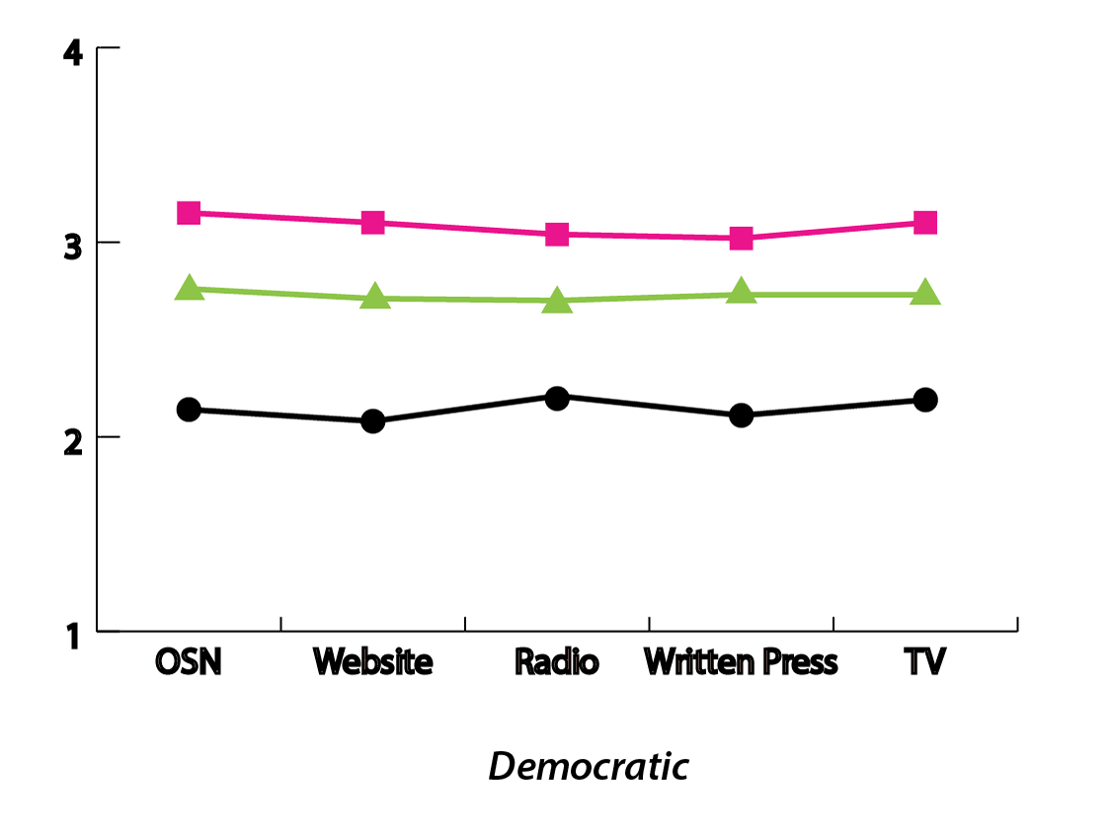 | 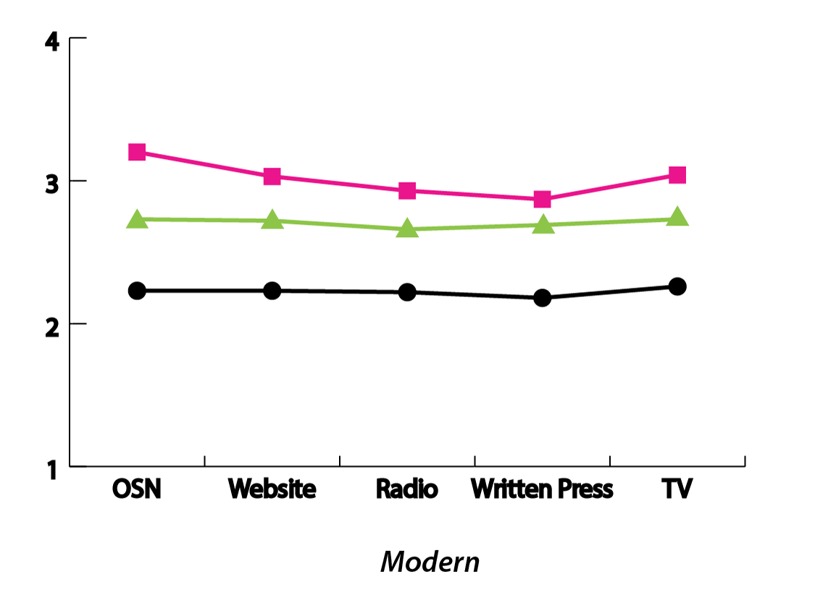 | 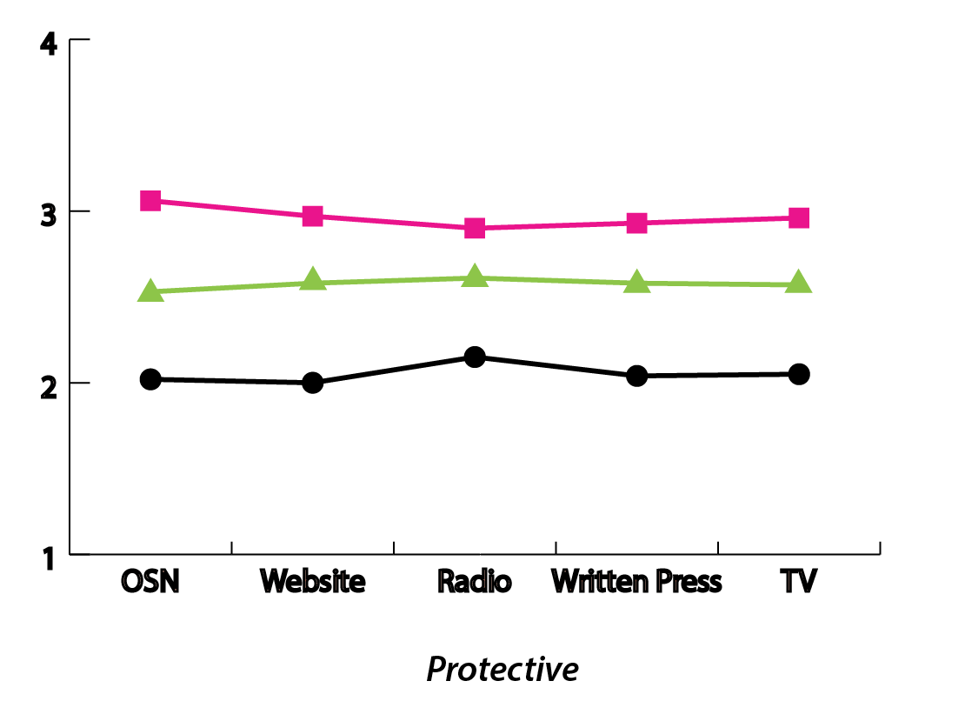
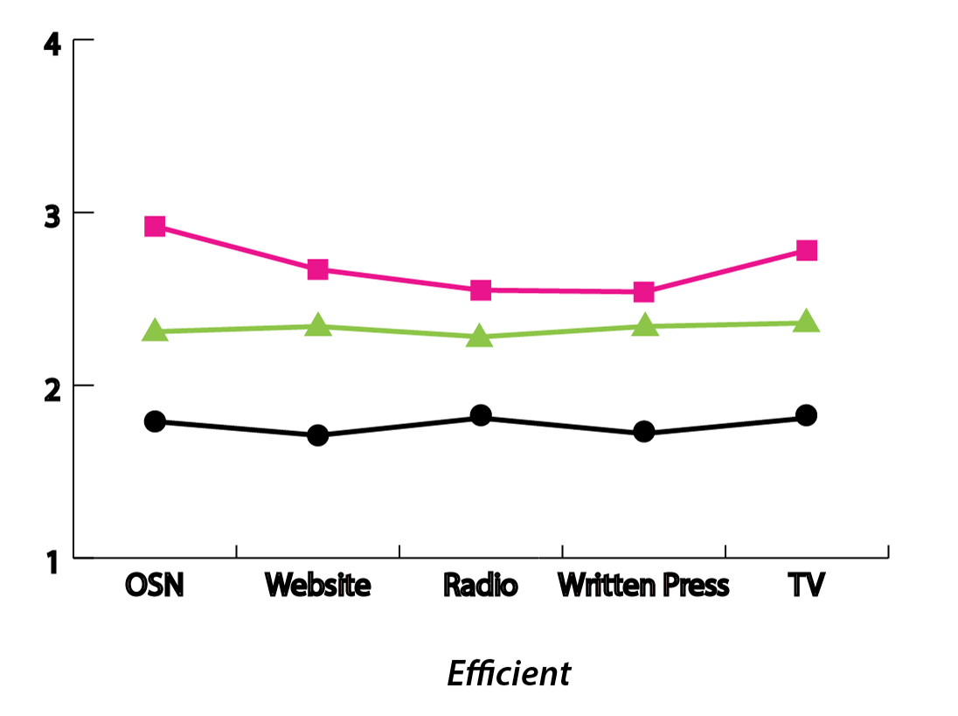 | 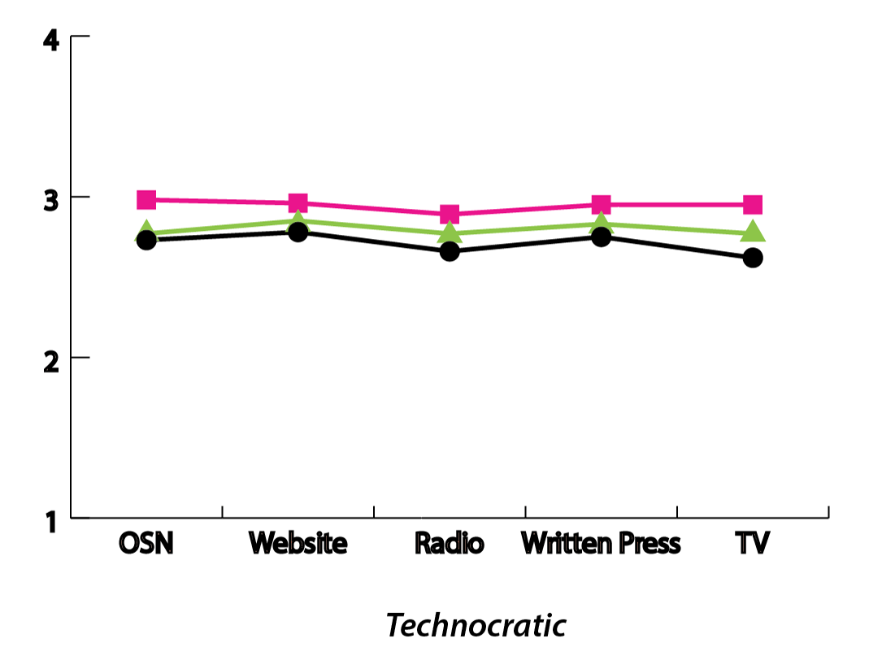 | 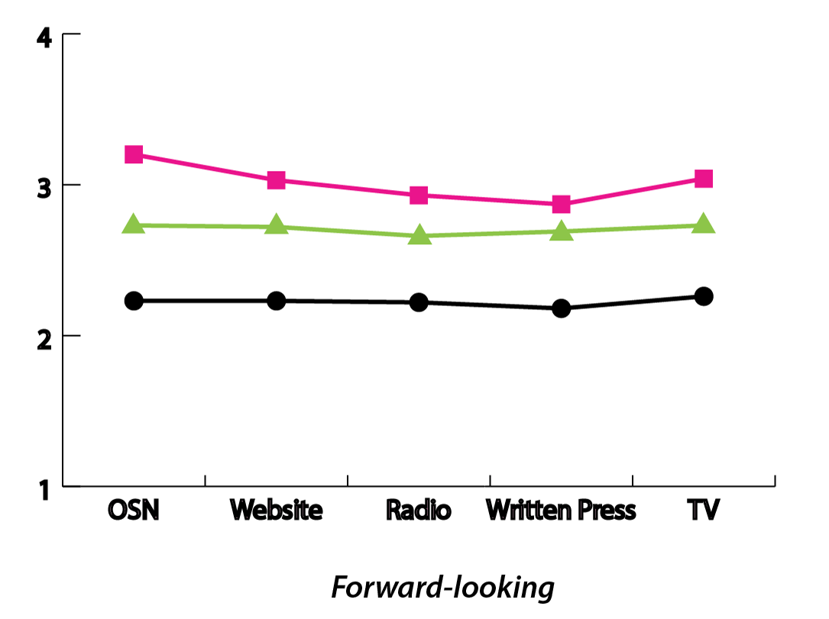

References
Allcott, Hunt, and Gentzkow, Matthew. 2017. “Social Media and Fake News in the 2016 Election.” The Journal of Economic Perspectives 31(2): 211-236.
Andris, C., Lee, D., Hamilton, M. J., Martino, M., Gunning, C. E., & Selden, J. A. (2015). The Rise of Partisanship and Super-Cooperators in the U.S. House of Representatives. PLOS ONE, 10(4). https://doi.org/10.1371/journal.pone.0123507.
Bae, Soo Young. 2017. “The Social Mediation of Political rumors: Examining the Dynamics in Social Media and Belief in Political Rumors.” Journalism, September.
Barberá, Pablo, John T. Jost, Jonathan Nagler, Joshua A. Tucker, and Richard Bonneau. 2015. “Tweeting From Left to Right: Is Online Political Communication More Than an Echo Chamber?” Psychological Science 26 (10): 1531–42.
Barbera, Pablo. 2015. “How Social Media Reduces Mass Political Polarization. Evidence from Germany, Spain, and the U.S.” Paper presented at the 2015 APSA Conference. Online: http://pablobarbera.com/static/barbera_polarization_APSA.pdf.
Bartlett, Bruce. 2015. “How Fox News changed American media and political dynamics.” SSRN, May 15. https://papers.ssrn.com/sol3/papers.cfm?abstract_id=2604679.
Bartlett, Bruce. 2016. “It’s Not Too Late To Fix Fox News.” New York Times, September 19. https://www.nytimes.com/2016/09/19/opinion/its-not-too-late-to-fix-fox-news.html.
Benkler, Yochai, Faris, Robert, Roberts, Hal, and Zuckerman, Ethan. 2017. “Study: Breitbart-Led Right- Wing Media Ecosystem Altered Broader Media Agenda.” Columbia Journalism Review. March 3. https://www.cjr.org/analysis/breitbart-media-trump-harvard-study.php
Bossetta, M., Segesten, A., and Trenz, H.J. 2017. Political Participation on Facebook during Brexit: Does User Engagement on Media Pages Stimulate Engagement with Campaigns? Journal of Language and Politics, 17(2): 173-199.
Bossetta, Michael, Segesten, Anamaria, Zimmerman, Chris & Bonacci, Duje. 2018. “Shouting at the wall: Does negativity drive ideological cross-posting in Brexit Facebook comments?” Proceedings of the International Conference on Social Media & Society, Copenhagen, Denmark (SMSociety).
Bruns, Axel. 2017. “Echo Chamber? What Echo Chamber? Reviewing the Evidence.” In 6th Biennial Future of Journalism Conference (FOJ17), 14-15 September 2017, Cardiff, UK.
Carlson, Matt. 2018. “Fake news as informational moral panic: the symbolic deviancy of social media during the 2016 presidential election.” Information, Communication and Society. Online-first version: https://www.tandfonline.com/doi/full/10.1080/1369118X.2018.1505934
Del Valle, Marc Esteve and Bravo, Rosa Borge. 2018. “Echo Chambers in Parliamentary Twitter networks: The Catalan Case.” International Journal of Communication 21(1): 1715-1735.
Dimitrova, Daniella, V., Shehata, Adam, Strömbäck, Jester, and Nord, Lars, W. 2014. “The Effects of Digital Media on Political Knowledge and Participation in Election Campaigns: Evidence from Panel Data.” Communication research 41(1): 95-118.
Dubois, Elizabeth and Blank, Grant, 2018. “The Echo Chamber Is Overstated: The Moderating Effect of Political Interest and Diverse Media.” Information, Communication & Society 21, 729–745.
Feller, Albert, Kuhnert, Matthias, Sprenger Tim O., and Welpe, Isabelle. 2011. “Divided They Tweet: The Network Structure of Political Microbloggers and Discussion Topics.” Proceedings of the Fifth International AAAI Conference on Weblogs and Social Media (ICWSM 11).
Foer, Franklin. 2017. “Facebook War on Free Will.” The Guardian, September 19. https://www.theguardian.com/technology/2017/sep/19/facebooks-war-on-free-will.
Gil de Zúñiga, Homero, Jung, Nakwon, and Valenzuela, Sebastian. 2012. “Social Media Use for News and Individuals' Social Capital, Civic Engagement and Political Participation.” Journal of Computer‐Mediated Communication 17(3): 319-336.
Groshek, Jacob and Koc-Michalska, Karolina. 2017. “Helping Populism Win? Social Media Use, Filter Bubbles and Support for Populist Presidential Candidates in the 2016 US Election Campaign.” Information, Communication & Society 20(9): 1389-1407.
Justwan, Florian, Bert Baumgaertner, Juliet E. Carlisle, April K. Clark, and Michael Clark. 2018. “Social Media Echo Chambers and Satisfaction with Democracy among Democrats and Republicans in the Aftermath of the 2016 US Elections.” Journal of Elections, Public Opinion and Parties. 28 (4): 424-442.
Keen, Andrew. 2007. The Cult of the Amateur: How Today’s Internet is Killing our culture and Assaulting our Economy. New York: Nicholas Brealey Publishing.
Kim, Yonghwan, Chen, Hsuan-Ting., and Gil De Zúñiga, Homero. 2013. “Stumbling Upon News on the Internet: Effects of Incidental News Exposure and Relative Entertainment Use on Political Engagement.” Computers in Human Behavior 29(6): 2607-2614.
Kuypers, Jim. 2014. Partisan Journalism: A History of Media Bias in the United States. Plymouth: Rowan and Littlefield.
Messing, Solomon & Westwood, Sean, J. 2014. “Selective Exposure in the Age of Social Media: Endorsements Trump Partisan Source Affiliation When Selecting News Online.” Communication Research 41(8): 1042-1063.
Pariser, Eli. 2011. The Filter Bubble: How the New Personalised Web is Changing What We Read and How We Think. New York: Penguin.
Preston, Peter. 2016. “Trust in the Media Is the First Casualty of the Post-Factual World.” The Guardian, September 24. https://www.theguardian.com/media/2016/sep/24/trust-in-media-first-casualty-post-factual-war-corbyn-trump.
Prior, Markus. 2013. “Media and political polarization.” Annual Review of Political Science 16, 101–127.
Reuters. 2016. “How One Pollster Correctly Predicts Both Trump’s Victory and Brexit.” Fortune, November 11. http://fortune.com/2016/11/11/pollster-brandseye-donald-trump-brexit-social-media/
Silverman, Craig. 2016. This Analysis Shows How Viral Fake Election News Stories Outperformed Real News on Facebook. BuzzFeed, November 26. https://www.buzzfeednews.com/article/craigsilverman/viral-fake-election-news-outperformed-real-news-on-facebook#.fxojJRybM.
Sykes, Charlie. 2017. How the Right Lost Its Mind. New York: St Martin’s Press.
Tait, Amelia. 2016. “Control, Alt-Right, Retweet: How Social Media Paved the Way for President Trump. The New Statesman, November 10. https://www.newstatesman.com/world/north-america/2016/11/control-alt-right-retweet-how-social-media-paved-way-president-trump.
The Economist. 2017a. “Scandal, Outrage, Politics: Do Social Media Threat Democracy?” November 17. https://www.economist.com/leaders/2017/11/04/do-social-media-threaten-democracy.
The Economist. 2017b. “Once Considered a Boon to Democracy, Social Media Have Started to Look Like Its Nemesis.” November 4. https://www.economist.com/briefing/2017/11/04/once-considered-a-boon-to-democracy-social-media-have-started-to-look-like-its-nemesis.
Turcotte, Jason, York, Chance, Irving, Jacob, Scholl, Roxane, M., and Pingree, Raymond, J. 2015. “News Recommendations from Social Media Opinion Leaders: Effects on Media Trust and Information Seeking.” Journal of Computer-Mediated Communication 20: 520–535.
Vaccari, Cristian, Valeriani, Augusto, Barberá, Pablo, Jost, John, T., Nagler, Jonathan, and Tucker, Joshua, A. 2016. “Of Echo Chambers and Contrarian Clubs: Exposure to Political Disagreement among German and Italian Users of Twitter.” Social Media and Society 2(3): 1-24.
Wolff, Michael. 2016. “Michael Wolff on Brexit: How “Stupid” Beat “Smart” Media (and How Trump Benefits).” The Holywood Reporter, June 27. https://www.hollywoodreporter.com/news/michael-wolff-brexit-why-stupid-906430.
Yang, JungHwan, Rojas, Hernado, Wojcieszak, Magdalena, Aalberg, Toril, Coen, Sharon, Curran, James, Hayashi, Kaori, Iengar, Shanto, Jones, Paul, K., Mazzoleni, Gianpietro, Papathanassopoulos, Stylianos, Rhee, June Woong, Rowe, David, Soroka, Stuart, Tiffen, Rodney. 2016. “Why Are “Others” So Polarized? Perceived Political Polarization and Media Use in 10 Countries.” Journal of Computer-Mediated Communication 21(5): 349-367.

Marie Le Pen’s Front National, for example, became the second largest political party in the 2017 French election thanks to its populist policies that, among other things, privilege French over foreigners and aim to take back powers from the EU to boost France’s global position.
A follow-up question – “Where do you get most of your news on EU political matters? Secondly?” – was asked but we were only interested in OSNs as the first primary source of EU politics news.
The critical value (alpha level) for statistical significance was set at .01 in all our data analysis.

